PARISH COUNCIL MTG: Mells November 2025

Number of Crimes by Offence Type:

No crimes to report for the month of November

Please note: ‘Violence Against a Person’ is a broad classification encompassing various incidents. These can range from physical altercations, such as one person striking another, to verbal disputes where someone shouts, causing another person to feel unsafe. It also includes situations where body language suggests intent to harm, as well as instances where an individual perceives a potential threat—perhaps due to a mental health episode

Number of Crimes Trend:

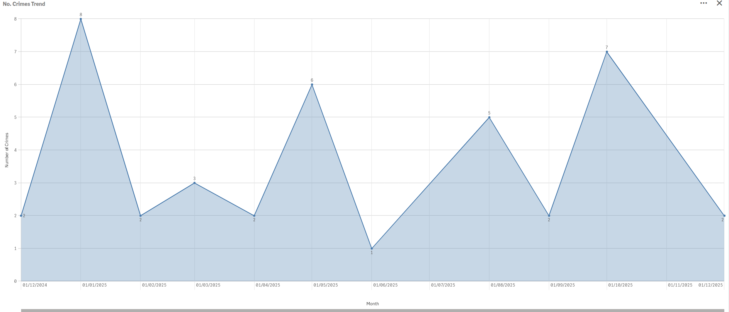

CURRENT PACT PRIORITIES:

Maintain a visible Police presence in Mells alongside monthly beat Surgeries in Mells Cafe

FUTURE PACT PRIORITIES:

Hare Coursing and poaching – Any sighted incidents or suspicious behaviour, please report.
Regular foot patrols are ongoing and productive community engagement.
Please remember to report Anti-Social-Behaviour and drug related incidents to 101 or 999, respectively.

OVERALL CRIME TRENDS

None of significant not

